

DUBLIN INSTITUTE OF TECHNOLOGY
_____________

DT228A/1 MSc in Computing
DT228B/1 MSc in Computing
DT228B/2 MSc in Computing
______________

SUPPLEMENTAL EXAMINATIONS 2017/2018
______________

Probability and Statistical Inference [Math9102]

Ms. Deirdre Lawless
Dr. Deirdre Lillis
Dr. Ignacio Castiñeiras

Date & Time TBA

Two Hours

SOLUTIONS
Instructions to candidates

Answer question one and one other question.

All questions carry equal marks.

Description of Dataset to be used in All Questions

A researcher wants to investigate salaries and the nature of employment security in the ICT sector in Ireland.
They have collected a dataset comprising 52 cases, each representing a single employee, which was constructed by conducting a survey in the Grand Canal Dock area of Dublin, which has a high representation of ICT companies, on a single day. Their intention is to conduct a statistical analysis of this dataset so that they can extrapolate their findings to the ICT sector in general in Ireland. It is estimated that approximately 105,000 people are currently employed in the ICT sector in Ireland. The gender ratio in the ICT Sector in Ireland is 81:19. Missing data is not a concern.
The researcher has developed a theory as part of their research that there is a correlation between years of experience and salary earned, that there is a difference in salary based on gender and that there is a difference in salary based on the nature of employment (temporary, contract ,permanent).
Traditionally a 5% cut-off level of statistical significance is used within the research domain.
In addition, while conducting this survey the researcher asked a range of Likert style questions designed to assess an employee’s level of satisfaction with their employment. Their intention is to undertake a dimension reduction using the resulting variables to uncover latent variables.

Variables of concern in the dataset
Name | Label | Values | Type
salary | Annual Salary |  | Scale
gender | Gender | 1=Female, 2=Male | Nominal
empstatus | Employment Status | 1=Temporary, 2=Contract, 3=Permanent | Nominal
exper | Years of experience |  | Scale
Variables Related to Survey on Employee Satisfaction with their Employment
att_1 | Attitude: Work Environment | 1(Extremely Satisfied) to 10 (Extremely Dis-satisfied) | Nominal
att_2 | Attitude: Salary | 1(Extremely Satisfied) to 10 (Extremely Dis-satisfied) | Nominal
att_3 | Attitude: Support from Management | 1(Extremely Satisfied) to 10 (Extremely Dis-satisfied) | Nominal
att_4 | Attitude: Clarity of Responsibilities | 1(Extremely Satisfied) to 10 (Extremely Dis-satisfied) | Nominal
att_5 | Attitude: Work Hours | 1(Extremely Satisfied) to 10 (Extremely Dis-satisfied) | Nominal
att_6 | Attitude: Company to Work for | 1(Extremely Satisfied) to 10 (Extremely Dis-satisfied) | Nominal

1. | (a) | Explain the concepts of representativeness, Type I and Type II errors and how they are related.  In your answer you should clearly explain the concepts of statistical significance and statistical power and how they are related to Type I and Type II errors  (10 marks)
Marking Scheme:  Representativeness: Sample reflects the population therefore needs to reflect the characteristics of that population so that findings can be extrapolated from the sample to the population.  Type I: incorrect rejection of correct null hypothesis.  Sig:; means the statistic is reliable to cut-off level can conclude level of evidence to reject null hypothesis to this level e.g. 5%=p value 0.05 ;  p value is the probability value is the probability of an outcome given the hypothesis  Type II: failure to reject null hypothesis.  The probability of a type II error is denoted by the beta symbol β  The power of any test of statistical significance is defined as the probability that it will reject a false null hypothesis.  Statistical power is inversely related to beta or the probability of making a Type II error. In short, power = 1 – β.  Type I level usually selected independently of sample size but should identify that increasing sample size makes it more likely to find significant results. Also should note the relationship between representativeness and Type I (non-representative sample may lead to finding an effect not present in population) |  |  | 2 marks  1 mark  1 mark  1 mark  1 mark  1 mark  1 mark  2 marks
 | (b) | Using the information provided in the descriptor on the previous page and the descriptive statistics in Appendix A.  Briefly discuss the suitability of the dataset collected for use in the proposed research.  Comment in particular on the representativeness of the sample and consider the potential for the occurrence of Type I and Type II errors and explain clearly how you would address any issues you identify.  (10 marks)
Marking Scheme:  Representativeness: method of sample collection is an issue; gender representation an issue.  Type I primary concern is alpha level – currently 0.05. 95% confidence – nothing hugely concerning here but the influence of the sample representativeness and size may be an issue.  Size of the sample n=52: may not be too small for the test but is it too small for credibility – should increase. For regression should be above 100, for EFA should be over 300  Potential solution representativeness– weighting for non-response, weighting for design effect, should recognise scaling up for population is not appropriate  Reducing Type I - reducing alpha level; improving representativeness  Reducing Type II – increasing sample size |  |  | 2 marks  2 mark  2 marks  2 marks  1 mark  1 mark

1. | (c) | - Explain the steps that you would need to take to develop and test hypotheses related to this theory.  Illustrate your answer by deriving and stating hypotheses related to the researcher’s theory using the statistics provided in in Appendix A.  (10 marks)  - Select and interpret the appropriate statistical test to test your hypotheses reporting your statistics according to APA guidelines.  Justify your selection based on your analysis of the descriptive statistics provided in Appendix A.  (15 marks)
Marking Scheme:  (i)  Hypothesis testing steps: Derive null and alternate hypotheses; identify type of test needed based on hypothesis; decide on cut-off and critical value; conduct the test to compute test statistic; interpret statistical significance and test statistic; conclude on whether to accept/reject null hypothesis.  Hypotheses  (Appropriate null hypotheses expected)  - HA: There is a relationship between a years of experience and salary  - HA: There is a difference in salary for respondents of different gender  - HA: There is a difference in salary for respondents of different employment status  (ii)  For each:  2 marks selecting correct test  2 marks justification  1 mark correct reporting |  |  | 4 marks  3 x 2 marks  3 x 5 marks
1. | (d) | Suppose the researcher extended their theory and proposes that a respondent’s employment status differs based on gender.  State clearly what type of statistical test could be used to test a related hypothesis and explain how this test works.  (5 marks)
Marking Scheme:  Chi-square test  Working with nominal data; Can’t use mean must use frequencies;  The null hypothesis is used to construct an idealized sample distribution of expected frequencies that describes how the sample would look if the data were in perfect agreement with the null hypothesis - that the proportions are the same for all populations  A chi-square statistic is computed to measure the amount of discrepancy between the ideal sample (expected frequencies from H0) and the actual sample data (the observed frequencies). |  |  | 1 mark  1 mark  2 marks  1 mark

2. | (a) | The researcher decided to build an inferential model to further explore the relationship between salary, experience and gender. They have created standardised scores for salary and years of experience. A dummy variable for gender dummyGender which has a value 0 for male and 1 for female has also been included.  The researcher first created a simple linear regression model including the standardised score for the years of experience and gender as predictor variables for the standardised score for salary.  - Explain what multiple linear regression will allow the researcher to do and what in this context prediction means.  (5 marks)  - Explain clearly why a dummy variable is needed for gender and what it will allow the researcher to explore.  (6 marks)
Marking Scheme:  (i)  Regression will allow researcher to explore how well a set of variables is able to predict an outcome variable; which variable in a set is the best predictor; whether a variable is still able to predict an outcome when controlling for a particular variables.  Prediction: looking at is the variance in the outcome variable and how much of the variance could be considered to be explained by the predictor variables. Should comment on variables involved.  (ii)  Dummy variable: interested in effect of characteristic, if include 1,2,3,4,5 etc. will act as multiplier, 0 and 1 can see effect and its absence;  Should address need to recode gender originally coded as 1 and 2  Should identify male (0) as reference category and female as category of interest (i)  Should identify need to explore a differential effect |  |  | 3 marks  2 marks  2 marks  2 marks  1 mark  1 mark

2. | (b) | Using the statistics provided in Appendix B:  - State the regression equation;  - Interpret the model for male and female respondents;  - Assess the fit and usefulness of the model considering the coefficients, r², adjusted r²and f statistic;  - Report the relevant statistics according to APA guidelines;  - Explain the concepts you use to assess the fit and usefulness of the model.  (30 marks)
Marking Scheme:  Regression Equation: zsalary=.658*zexperience-1.097dummygender  Interpretation of equation: Should plug in male and female and interpret meaning.  Assessing fit and usefulness:  F statistic: should report F plus dfs plus statistical significance  Adjusted R2: Should state % variance explained  Coefficients: Should state betas and significance and comment on significance  Reporting according to APA guidelines  F statistic: Whether the model as a whole predicts the dependent variable; Its statistical significance is the significance of the model; Model is significant  Coefficients: Measure the strength and direction of relationships between independent variables and the dependent variance – need to consider the significance of these. Even though the gender variable is not a significant predictor, should recognise need to include it as a control.  R2: the proportion of variance in the outcome (dependent) variable which can be explained by the predictor (independent) variables. An R2 of 1 means the independent variable explains 100% of the variance in the dependent variable. Conversely 0 means it explains none. Adjusted R square – takes account of multiple variables. Model explains 10.2% of variance |  |  | 3 marks  6 marks  3 marks  3 marks  3 marks  3 marks  3 marks  3 marks  3 marks

2. | (c) | Two major concerns for multiple linear regression are multicollinearity and outliers.  Explain these concerns and why they are important and what can be done to address these concerns.  Illustrate your answer by assessing these concerns for the model created in part (a) referring to the information provided in Appendix B.  (9 marks)
Marking Scheme:  Multicollinearity: Occurs when two or more independent variables contain strongly redundant information; If variables are collinear then it means there is not enough distinct information in these variables for MLR to operate – they are essentially measuring the same thing;  Consider: VIF = variance inflation factors - Tells you what the standard error would be if the variable was uncorrelated with others; Values of VIF that exceed 2.5 should be cause for concern;  Tolerance – should be concerned if it is lower than 0.4. If it is a concern you need to analyse your variables in separate regression equations and then examine how they operate.  No issues for this data  Outliers: MLR can be greatly influenced by outliers - They ‘pull’ the equation away from the general pattern  Look at the Minimum and Maximum values next to Std. Residual (Standardised Residual) subheading. +/- 1.96 95%, +/- 3.29 99%  Sometimes it is reasonable to delete the outliers; Sometimes you need to retain the outlier – it may be your most important observation; Sometimes it is a good idea to do your analysis twice – once with and once without the outlier to see how much influence it is having on the model.  Std. residuals are outside +/-1.96, given the dataset size this is a concern |  |  | 2 marks  1 mark  1 mark  1 mark  1 mark  1 mark  1 mark  1 mark

3. |  | As part of their survey the researcher has collected data on employee satisfaction with their employment. They conducted a survey using an attitudinal scale (captured in variables att_1 to att_6). They wish to incorporate measures of employee satisfaction with their employment into inferential models without including all variables. They wish to conduct an exploratory factor analysis on these variables.  Explain clearly the objectives of exploratory factor analysis and principal component analysis, the difference between the two approaches and when you would use each technique.  (12 marks)
Marking Scheme:  Objectives: Reduce the number of variables; Evaluates the construct validity of a scale, test, or instrument; Development of parsimonious (simple) analysis and interpretation; Addresses multicollinearity (two or more variables that are correlated)  Differences/Use EFA and PCA:  EFA Determine the nature of and the number of latent variables that account for observed variation and covariation among set of observed indicators;  Only shared variance is used;  Used to develop theoretical constructs; Used to prove/disprove proposed theories;  Models observed variables in terms of factors  PCA Reduce multiple observed variables into fewer components that summarize their variance;  Models factors in terms of observed variables  All of the variance in the variables is used  Typically data reduction |  |  | 3 marks  2 marks  1 mark  1 mark  1 mark  1 mark  1 mark  1 mark  1 mark

3. |  | Explain how you would assess the suitability of a dataset and the reliability of a scale for use in exploratory factor analysis.  Explain any concepts you use within your analysis.  Illustrate your answer by assessing the dataset used by the researcher using the additional statistics and graphs provided in Appendix C.  (21 marks)
Marking Scheme:  Sample size, sample to variable: generally at least 300 cases needed; N:p ratio where N = no of cases, p=no of variables rule of thumb 10:1. Alternate rules may be accepted;  Factorability of the matrix: looking at relationships between individual variable; correlation coefficients >0.30 indicates that the factors account for approximately 30% relationship within the data, or in a practical sense, it would indicate that a third of the variables share too much variance – good indicator for EFA. If no correlations need to rethink use of EFA. Need to identify correlations  KMO proportion of variance in variables that might be caused by an underlying factor. High values close to 1 suggest that FA useful, anything less than 0.5 FA won’t be useful.  Bartlett tests that variables are correlated. Looking for a statistically significant p value which suggests that they are related and a FA would be useful.  Reliability accuracy and precision of a measurement procedure; Cronbach’s alpha – index of reliability associated with the variation accounted for by the true score of the "underlying construct"; Acceptable level depend on the purpose of the instrument.  Assessment on each element  Should draw a conclusion about the dataset suitability |  |  | 2 marks  2 marks  2 marks  2 marks  2 marks  5 x 2 marks  1 mark

3. |  | Suppose the researcher conducted an Exploratory Factor Analysis on these variables using Principal Axis Factoring as the extraction method and Varimax as the rotation.  Explain how factor analysis works focusing on extraction and loading.  In your answer explain clearly the concept of a factor.  Illustrate your answer by interpreting the output of the factor analysis conducted for this research using the information provided in Appendix C.  (17 marks)
Marking Scheme:  Factor: uncorrelated variable constructed from a set of correlated variables by considering pattern of shared variance – represent underlying structures within data contained in set of correlated variables.  Extraction: aim is reduce a large number of items into factors. Need to decide how many factors to retain. Criteria for extraction: Kaiser’s criteria (eigenvalue > 1 rule), the Scree test, the cumulative percent of variance extracted.  Eigenvalues: are the variances of the factors. A larger eigenvalue means that that factor explains a large amount of the variance in the data.  Variance: Looking at total variance explained for factors with eigenvalues > 1; factor 1-? explains x% of total variance; Rotation equalises the importance of the factors.  Communalities: proportion of the common variance within a variable; looking at extraction column  Factor Loadings: Correlation between a specific observed variable and a specific factor. Higher values mean a closer relationship.  Should consider communalities and loadings (initial and extraction)  Should consider the factor loadings  Should draw conclusions about the number of factors (1)  Should consider variance explained (37.22%)  Should name the factor |  |  | 2 marks  2 marks  2 marks  2 marks  2 marks  2 marks  1 mark  1 mark  1 mark  1 mark  1 mark

Descriptive Statistics
   |  | Years of experience | Annual salary in euros
  N | Valid | 52 | 52
  N | Missing | 0 | 0
  Mean |  | 16.12 | 23797.65
  Median |  | 15.50 | 23719.00
  Mode |  | 1ª | 28200
  Std. Deviation |  | 10.222 | 5917.289
  Variance |  | 104.496 | 35014310.937
  Skewness |  | 0.077 | 0.475
  Std. Error of Skewness |  | 0.330 | 0.330
  Kurtosis |  | -1.123 | -0.433
  Std. Error of Kurtosis |  | 0.650 | 0.650
  Range |  | 34 | 23045
  Percentiles | 25 | 6.25 | 18132.25
  Percentiles | 50 | 15.50 | 23719.00
  Percentiles | 75 | 23.75 | 27725.50
  a. Multiple modes exist. The smallest value is shown
  Employment Status
   |  | Frequency | Cumulative Percent
  Valid | Temporary | 18 | 34.6
  Valid | Contract | 14 | 26.9
  Valid | Permanent | 20 | 38.5
  Valid | Total | 52 | 100.0
  Gender
   |  | Frequency | Cumulative Percent
  Valid | Female | 14 | 26.9
  Valid | Male | 38 | 73.1
  Valid | Total | 52 | 100.0
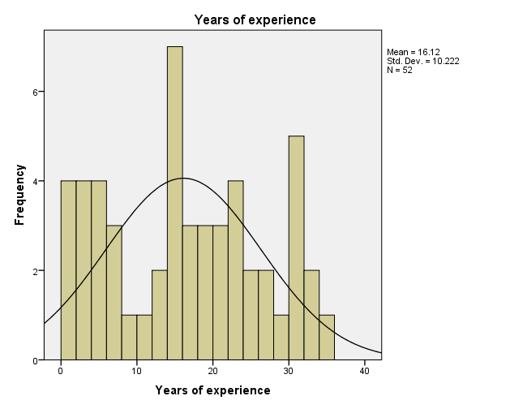 | 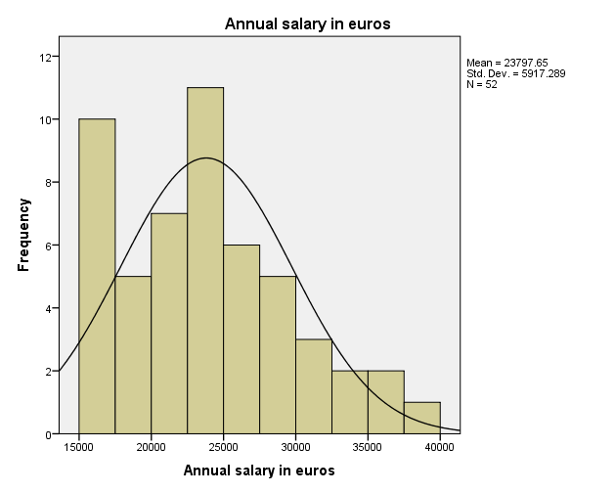

  Years of experience
   |  | Frequency | Cumulative Percent
  Valid | 1 | 4 | 7.7
  Valid | 2 | 2 | 3.8
  Valid | 3 | 2 | 3.8
  Valid | 4 | 3 | 5.8
  Valid | 5 | 1 | 1.9
  Valid | 6 | 1 | 1.9
  Valid | 7 | 2 | 3.8
  Valid | 9 | 1 | 1.9
  Valid | 11 | 1 | 1.9
  Valid | 12 | 1 | 1.9
  Valid | 13 | 1 | 1.9
  Valid | 14 | 4 | 7.7
  Valid | 15 | 3 | 5.8
  Valid | 16 | 1 | 1.9
  Valid | 17 | 2 | 3.8
  Valid | 18 | 2 | 3.8
  Valid | 19 | 1 | 1.9
  Valid | 20 | 1 | 1.9
  Valid | 21 | 2 | 3.8
  Valid | 22 | 2 | 3.8
  Valid | 23 | 2 | 3.8
  Valid | 24 | 2 | 3.8
  Valid | 27 | 2 | 3.8
  Valid | 29 | 1 | 1.9
  Valid | 30 | 2 | 3.8
  Valid | 31 | 3 | 5.8
  Valid | 32 | 1 | 1.9
  Valid | 33 | 1 | 1.9
  Valid | 35 | 1 | 1.9
  Valid | Total | 52 | 100.0
  Annual salary in euros
   |  | Frequency | Cumulative Percent
  Valid | 15000 | 1 | 1.9
   | 15350 | 1 | 1.9
   | 16094 | 1 | 1.9
   | 16150 | 1 | 1.9
   | 16244 | 1 | 1.9
   | 16500 | 1 | 1.9
   | 16686 | 1 | 1.9
   | 16700 | 1 | 1.9
   | 17095 | 1 | 1.9
   | 17250 | 1 | 1.9
   | 17600 | 1 | 1.9
   | 18000 | 1 | 1.9
   | 18075 | 1 | 1.9
   | 18304 | 1 | 1.9
   | 19175 | 1 | 1.9
   | 20300 | 1 | 1.9
   | 20525 | 1 | 1.9
   | 20690 | 1 | 1.9
   | 20850 | 1 | 1.9
   | 20999 | 1 | 1.9
   | 21600 | 1 | 1.9
   | 22450 | 1 | 1.9
   | 22906 | 1 | 1.9
   | 23300 | 1 | 1.9
   | 23712 | 1 | 1.9
   | 23713 | 1 | 1.9
   | 23725 | 1 | 1.9
   | 24450 | 1 | 1.9
   | 24742 | 1 | 1.9
   | 24750 | 1 | 1.9
  Annual salary in euros
   |  | Frequency | Cumulative Percent
   | 24800 | 1 | 1.9
   | 24832 | 1 | 1.9
   | 24900 | 1 | 1.9
   | 25400 | 1 | 1.9
   | 25500 | 1 | 1.9
   | 25748 | 1 | 1.9
   | 26182 | 1 | 1.9
   | 26775 | 1 | 1.9
   | 27025 | 1 | 1.9
   | 27959 | 1 | 1.9
   | 28200 | 2 | 3.8
   | 28516 | 1 | 1.9
   | 29342 | 1 | 1.9
   | 31114 | 1 | 1.9
   | 31850 | 1 | 1.9
   | 31909 | 1 | 1.9
   | 32850 | 1 | 1.9
   | 33696 | 1 | 1.9
   | 35350 | 1 | 1.9
   | 36350 | 1 | 1.9
   | 38045 | 1 | 1.9
   | Total | 52 | 100.0

 | Mann-Whitney Test
  Correlations
   |  |  | Annual salary in euros
  Spearman's rho | Years of experience | Correlation Coefficient | .679**
  Spearman's rho | Years of experience | Sig. (2-tailed) | 0.000
  Spearman's rho | Years of experience | N | 52
  Pearson Correlation | Years of experience | Correlation Coefficient | .675**
   |  | Sig. (2-tailed) | 0.000
   |  | N | 52
  Ranks
  Gender |  | N | Mean Rank | Sum of Ranks
  Years of experience | Female | 14 | 24.14 | 338.00
  Years of experience | Male | 38 | 27.37 | 1040.00
  Years of experience | Total | 52
  Annual salary in euros | Female | 14 | 19.50 | 273.00
  Annual salary in euros | Male | 38 | 29.08 | 1105.00
  Annual salary in euros | Total | 52
  Test Statisticsª
   | Years of experience | Annual salary in euros
  Mann-Whitney U | 233.000 | 168.000
  Wilcoxon W | 338.000 | 273.000
  Z | -0.681 | -2.022
  Asymp. Sig. (2-tailed) | 0.496 | 0.043
  a. Grouping Variable: Gender
Independent Samples Test (Grouping Variable Gender)
 |  | Levene's Test for Equality of Variances |  | t-test for Equality of Means
 |  | F | Sig. | t | df | Sig. (2-tailed) | Mean Difference | Std. Error Difference | 95% Confidence Interval of the Difference
 |  |  |  |  |  |  |  |  | Lower | Upper
Years of experience | Equal variances assumed | 2.665 | 0.109 | -0.627 | 50 | 0.534 | -2.015 | 3.215 | -8.473 | 4.443
Years of experience | Equal variances not assumed |  |  | -0.553 | 18.874 | 0.587 | -2.015 | 3.644 | -9.645 | 5.615
Annual salary in euros | Equal variances assumed | 0.000 | 0.985 | -1.847 | 50 | 0.071 | -3339.647 | 1807.716 | -6970.550 | 291.257
Annual salary in euros | Equal variances not assumed |  |  | -1.774 | 21.591 | 0.090 | -3339.647 | 1882.087 | -7247.147 | 567.854

ANOVA
Annual salary in euros (grouped by employment status)
Mean SquareFSig.
Between GroupsSum of Squaresdf | 1346783799.891 | 2 | 673391899.945 | 75.171 | 0.000
Within Groups | 438946057.879 | 49 | 8958082.814
Total | 1785729857.769 | 51

Multiple Comparisons
Dependent Variable: Annual salary in euros
Tukey HSD
(I) Employment Status | (J) Employment Status | Mean Difference (I-J) | Std. Error | Sig. | 95% Confidence Interval
 |  |  |  |  | Lower Bound | Upper Bound
Temporary | Contract | -5407.262 | 1066.553 | 0.000 | -7985.04 | -2829.49
Temporary | Permanent | -11890.28 | 972.407 | 0.000 | -14240.52 | -9540.05
Contract | Temporary | 5407.262 | 1066.553 | 0.000 | 2829.49 | 7985.04
Contract | Permanent | -6483.021 | 1042.961 | 0.000 | -9003.78 | -3962.27
Permanent | Temporary | 11890.283 | 972.407 | 0.000 | 9540.05 | 14240.52
Permanent | Contract | 6483.021 | 1042.961 | 0.000 | 3962.27 | 9003.78

Kruskal Wallis Test
  Ranks
  Employment Status |  | N | Mean Rank
  Annual salary in euros | Temporary | 18 | 10.17
  Annual salary in euros | Contract | 14 | 25.29
  Annual salary in euros | Permanent | 20 | 42.05
  Annual salary in euros | Total | 52
  Test Statistics^{a,b}
   | Annual salary in euros
  Chi-Square | 42.057
  df | 2
  Asymp. Sig. | 0.000
  a. Kruskal Wallis Test
  b. Grouping Variable: Employment Status

Model Summary^{b}
Model | R | R Square | Adjusted R Square | Std. Error of the Estimate
1 | .702ª | 0.493 | 0.472 | 0.72639108
a. Predictors: (Constant), dummyGender, Zscore: Zscore: Years of experience
b. Dependent Variable: Zscore: Zscore: Annual salary in euros

ANOVAª
Model |  | Sum of Squares | df | Mean Square | F | Sig.
1 | Regression | 25.145 | 2 | 12.573 | 23.828 | .000^{b}
1 | Residual | 25.855 | 49 | 0.528
1 | Total | 51.000 | 51
a. Dependent Variable: Zscore: Zscore: Annual salary in euros
b. Predictors: (Constant), dummyGender, Zscore: Zscore: Years of experience

Coefficientsª
Model |  | Unstandardized Coefficients |  | Standardized Coefficients | t | Sig. | Collinearity Statistics
 |  | B | Std. Error | Beta | t | Sig. | Tolerance | VIF
1 | (Constant) | 0.117 | 0.118 |  | 0.992 | 0.326
1 | Zscore: Zscore: Years of experience | 0.658 | 0.102 | 0.658 | 6.440 | 0.000 | 0.992 | 1.008
1 | dummyGender | -0.435 | 0.228 | -0.195 | -1.907 | 0.062 | 0.992 | 1.008
a. Dependent Variable: Zscore: Zscore: Annual salary in euros

 | 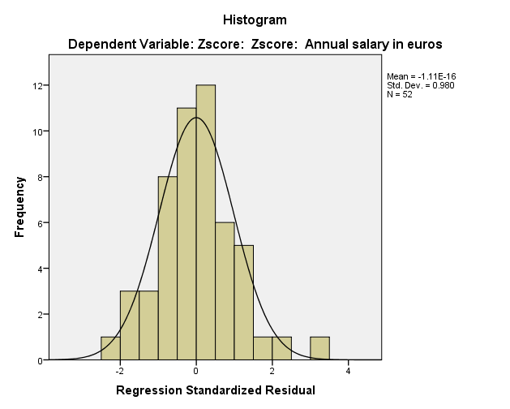
  Residuals Statisticsª
   | Minimum | Maximum | Mean | Std. Deviation | N
  Predicted Value | -1.2901621 | 1.3320054 | 0.0000000 | 0.70217372 | 52
  Residual | -1.62772846 | 2.21818662 | 0.00000000 | 0.71200567 | 52
  Std. Predicted Value | -1.837 | 1.897 | 0.000 | 1.000 | 52
  Std. Residual | -2.241 | 3.054 | 0.000 | 0.980 | 52
  a. Dependent Variable: Zscore: Zscore: Annual salary in euros

KMO and Bartlett's Test
  Kaiser-Mayer-Olkin Measure of Sampling Adequacy
  0.723Bartlett's Test of Sphericity Approx Chi-Square | 289.599
  df | 15
  Sig. | 0
  Correlation Matrix
   |  | Attitude: Work Environment | Attitude: Salary | Attitude: Support from Management | Attitude: Clarity of Responsibilities | Attitude: Work Hours | Attitude: Company to Work for
  Correlation | Attitude: Work Environment | 1 | 0.22 | 0.324 | 0.129 | 0.247 | 0.05
   | Attitude: Salary | 0.22 | 1 | 0.514 | 0.348 | 0.364 | 0.551
   | Attitude: Support from Management | 0.324 | 0.514 | 1 | 0.269 | 0.435 | 0.448
   | Attitude: Clarity of Responsibilities | 0.129 | 0.348 | 0.269 | 1 | 0.557 | 0.294
   | Attitude: Work Hours | 0.247 | 0.364 | 0.435 | 0.557 | 1 | 0.464
   | Attitude: Company to Work for | 0.05 | 0.551 | 0.448 | 0.294 | 0.464 | 1
  Determinant=.195
  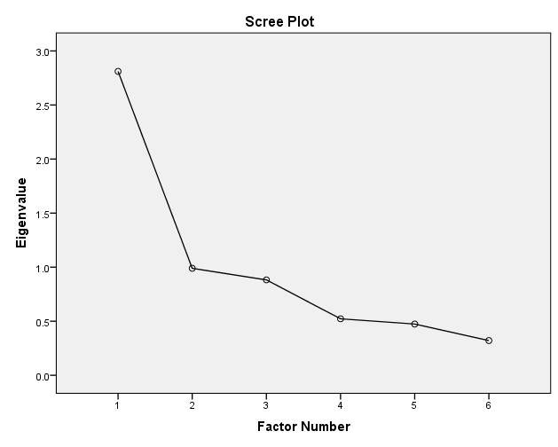
  Communalities
   | Initial | Extraction
  Attitude: Work Environment | 0.156 | 0.091
  Attitude: Salary | 0.425 | 0.48
  Attitude: Support from Management | 0.385 | 0.451
  Attitude: Clarity of Responsibilities | 0.338 | 0.289
  Attitude: Work Hours | 0.46 | 0.493
  Attitude: Company to Work for | 0.421 | 0.429
Factor Matrix
 | Factor
 | 1
Attitude: Work Environment | 0.702
Attitude: Salary | 0.693
Attitude: Support from Management | 0.672
Attitude: Clarity of Responsibilities | 0.655
Attitude: Work Hours | 0.537
Attitude: Company to Work for | 0.302

Total Variance Explained
 | Initial Eigenvalues |  |  | Extraction Sums of Squared Loadings
Factor | Total | % of Variance | Cumulative % | Total | % of Variance | Cumulative %
1 | 2.811 | 46.849 | 46.849 | 2.233 | 37.225 | 37.225
2 | 0.989 | 16.491 | 63.34
3 | 0.882 | 14.704 | 78.044
4 | 0.522 | 8.708 | 86.751
5 | 0.474 | 7.898 | 94.65
6 | 0.321 | 5.35 | 100

 | 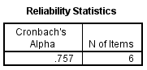
  Item-Total Statistics
   | Cronbach's Alpha if Item Deleted
  Attitude: Work Environment | 0.781
  Attitude: Salary | 0.692
  Attitude: Support from Management | 0.693
  Attitude: Clarity of Responsibilities | 0.74
  Attitude: Work Hours | 0.696
  Attitude: Company to Work for | 0.717

